

UNIVERSIDADE ESTADUAL DA PARAÍBA

CENTRO DE CIÊNCIAS E TECNOLOGIA

CIÊNCIA DA COMPUTAÇÃO

LUCAS DE LUCENA SIQUEIRA

[DANIEL XAVIER BRITO DE ARAUJO](mailto:daniel.araujo@aluno.uepb.edu.br)

ATAL - Exercício 1

CAMPINA GRANDE

2022

1. Análise assintótica

|  | Θ | O | o | Ω | ω |
| --- | --- | --- | --- | --- | --- |
| $5n² + 8$ | $n²$ | $n²$ | $n³$ | $n²$ | $n$ |
| $7n^{4} + 5n² + 8$ | $n^{4}$ | $n^{4}$ | $n^{5}$ | $n^{4}$ | $n^{3}$ |
| ${7n.log}_{n}+ 5n$ | ${n.log}_{n}$ | ${n.log}_{n}$ | ${n².log}_{n}$ | ${n.log}_{n}$ | ${n^{-1}.log}_{n}$ |
| $2^{n} + \log_{n}$ | $2^{n}$ | $2^{n}$ | $2^{2n}$ | $2^{n}$ | $n^{10}$ |
| ${8n.log}_{n}$ | ${n.log}_{n}$ | ${n.log}_{n}$ | ${n².log}_{n}$ | ${n.log}_{n}$ | ${n^{-1}.log}_{n}$ |

2 - Aplicação dos algoritmos de ordenação nos seguintes conjuntos de números:

* [50, 22, 85, 14, 31, 20]
* [35, 77, 44, 38, 22, 56]
* Bubble Sort

[50, 22, 85, 14, 31, 20] → [50, 22, 85, 14, 31, 20] → [22, 50, 85, 14, 31, 20] →

[22, 50, 85, 14, 31, 20] → [22, 50, 85, 14, 31, 20] → [22, 50, 85, 14, 31, 20] →

[22, 50, 14, 85, 31, 20] → [22, 50, 14, 85, 31, 20] → [22, 50, 14, 31, 85, 20] →

[22, 50, 14, 31, 85, 20] → [22, 50, 14, 31, 20, 85] → [22, 50, 14, 31, 20, 85] →

[22, 50, 14, 31, 20, 85] → [22, 50, 14, 31, 20, 85] → [22, 14, 50, 31, 20, 85] →

[22, 14, 50, 31, 20, 85] → [22, 14, 31, 50, 20, 85] → [22, 14, 31, 50, 20, 85] →

[22, 14, 31, 20, 50, 85] → [22, 14, 31, 20, 50, 85] → [14, 22, 31, 20, 50, 85] →

[14, 22, 31, 20, 50, 85] → [14, 22, 31, 20, 50, 85] → [14, 22, 20, 31, 50, 85] →

[14, 22, 20, 31, 50, 85] → [14, 22, 20, 31, 50, 85] → [14, 20, 22, 31, 50, 85] →

[14, 20, 22, 31, 50, 85] → [14, 20, 22, 31, 50, 85] → [14, 20, 22, 31, 50, 85]

[35, 77, 44, 38, 22, 56] → [35, 77, 44, 38, 22, 56] → [35, 77, 44, 38, 22, 56] →

[35, 44, 77, 38, 22, 56] → [35, 44, 77, 38, 22, 56] → [35, 44, 38, 77, 22, 56] →

[35, 44, 38, 77, 22, 56] → [35, 44, 38, 77, 22, 56] → [35, 44, 38, 22, 77, 56] →

[35, 44, 38, 22, 77, 56] → [35, 44, 38, 22, 56, 77] → [35, 44, 38, 22, 56, 77] →

[35, 44, 38, 22, 56, 77] → [35, 38, 44, 22, 56, 77] → [35, 38, 44, 22, 56, 77] →

[35, 38, 22, 44, 56, 77] → [35, 38, 22, 44, 56, 77] → [35, 38, 22, 44, 56, 77] →

[35, 38, 22, 44, 56, 77] → [35, 38, 22, 44, 56, 77] → [35, 22, 38, 44, 56, 77] →

[35, 22, 38, 44, 56, 77] → [35, 22, 38, 44, 56, 77] → [35, 22, 38, 44, 56, 77] →

[22, 35, 38, 44, 56, 77] → [22, 35, 38, 44, 56, 77] → [22, 35, 38, 44, 56, 77] →

[22, 35, 38, 44, 56, 77]

* Selection Sort

[50, 22, 85, 14, 31, 20] → [50, 22, 85, 14, 31, 20] → [14, 22, 85, 50, 31, 20] →

[14, 22, 85, 50, 31, 20] → [14, 20, 85, 50, 31, 22] → [14, 20, 85, 50, 31, 22] →

[14, 20, 22, 50, 31, 85] → [14, 20, 22, 50, 31, 85] → [14, 20, 22, 31, 50, 85] →

[14, 20, 22, 31, 50, 85]

[35, 77, 44, 38, 22, 56] → [35, 77, 44, 38, 22, 56] → [22, 77, 44, 38, 35, 56] →

[22, 77, 44, 38, 35, 56] → [22, 35, 44, 38, 77, 56] → [22, 35, 44, 38, 77, 56] →

[22, 35, 38, 44, 77, 56] → [22, 35, 38, 44, 77, 56] → [22, 35, 38, 44, 56, 77]

* Insertion Sort

[50, 22, 85, 14, 31, 20] → [50, 22, 85, 14, 31, 20] → [22, 50, 85, 14, 31, 20] →

[22, 50, 85, 14, 31, 20] → [22, 50, 85, 14, 31, 20] → [22, 50, 14, 85, 31, 20] →

[22, 50, 14, 85, 31, 20] → [22, 14, 50, 85, 31, 20] → [22, 14, 50, 85, 31, 20] →

[14, 22, 50, 85, 31, 20] → [14, 22, 50, 85, 31, 20] → [14, 22, 50, 85, 31, 20] →

[14, 22, 50, 31, 85, 20] → [14, 22, 50, 31, 85, 20] → [14, 22, 50, 31, 85, 20] →

[14, 22, 31, 50, 85, 20] → [14, 22, 31, 50, 85, 20] → [14, 22, 31, 50, 20, 85] →

[14, 22, 31, 50, 20, 85] → [14, 22, 31, 20, 50, 85] → [14, 22, 31, 20, 50, 85] →

[14, 22, 20, 31, 50, 85] → [14, 22, 20, 31, 50, 85] → [14, 20, 22, 31, 50, 85] →

[14, 20, 22, 31, 50, 85]

[35, 77, 44, 38, 22, 56] → [35, 77, 44, 38, 22, 56] → [35, 77, 44, 38, 22, 56] →

[35, 44, 77, 38, 22, 56] → [35, 44, 77, 38, 22, 56] → [35, 44, 38, 77, 22, 56] →

[35, 38, 44, 77, 22, 56] → [35, 38, 44, 77, 22, 56] → [35, 38, 44, 22, 77, 56] →

[35, 38, 44, 22, 77, 56] → [35, 38, 22, 44, 77, 56] → [35, 38, 22, 44, 77, 56] →

[35, 22, 38, 44, 77, 56] → [35, 22, 38, 44, 77, 56] → [22, 35, 38, 44, 77, 56] →

[22, 35, 38, 44, 77, 56] → [22, 35, 38, 44, 56, 77] → [22, 35, 38, 44, 56, 77]

* Merge Sort

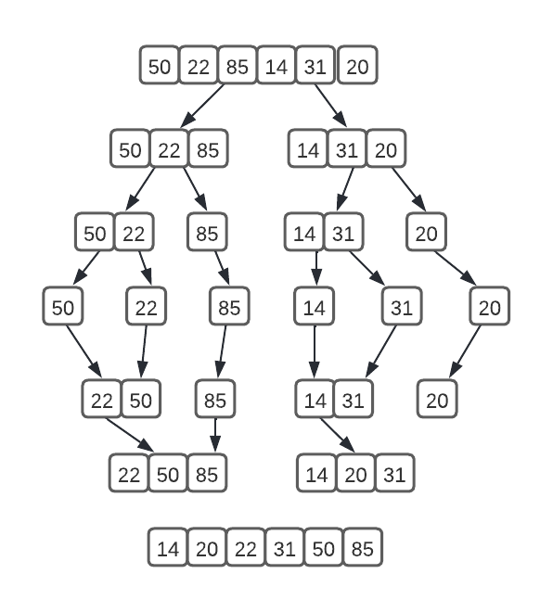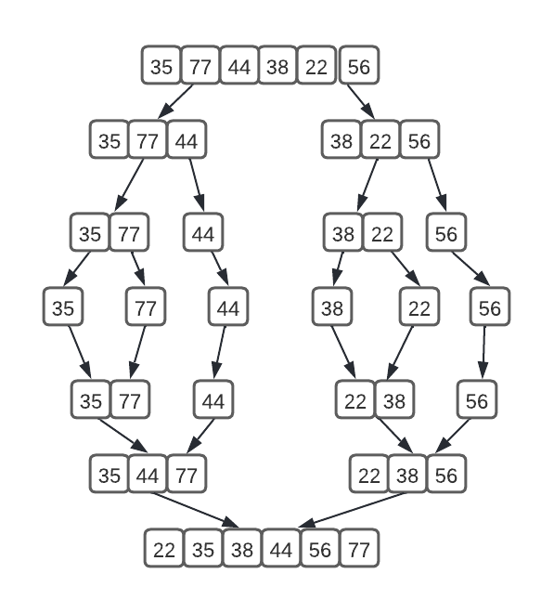

3 -

Insira os elementos 32, 45, 17, 2, 5 na heap seguinte. Mostre visualmente como a heap fica após cada operação.

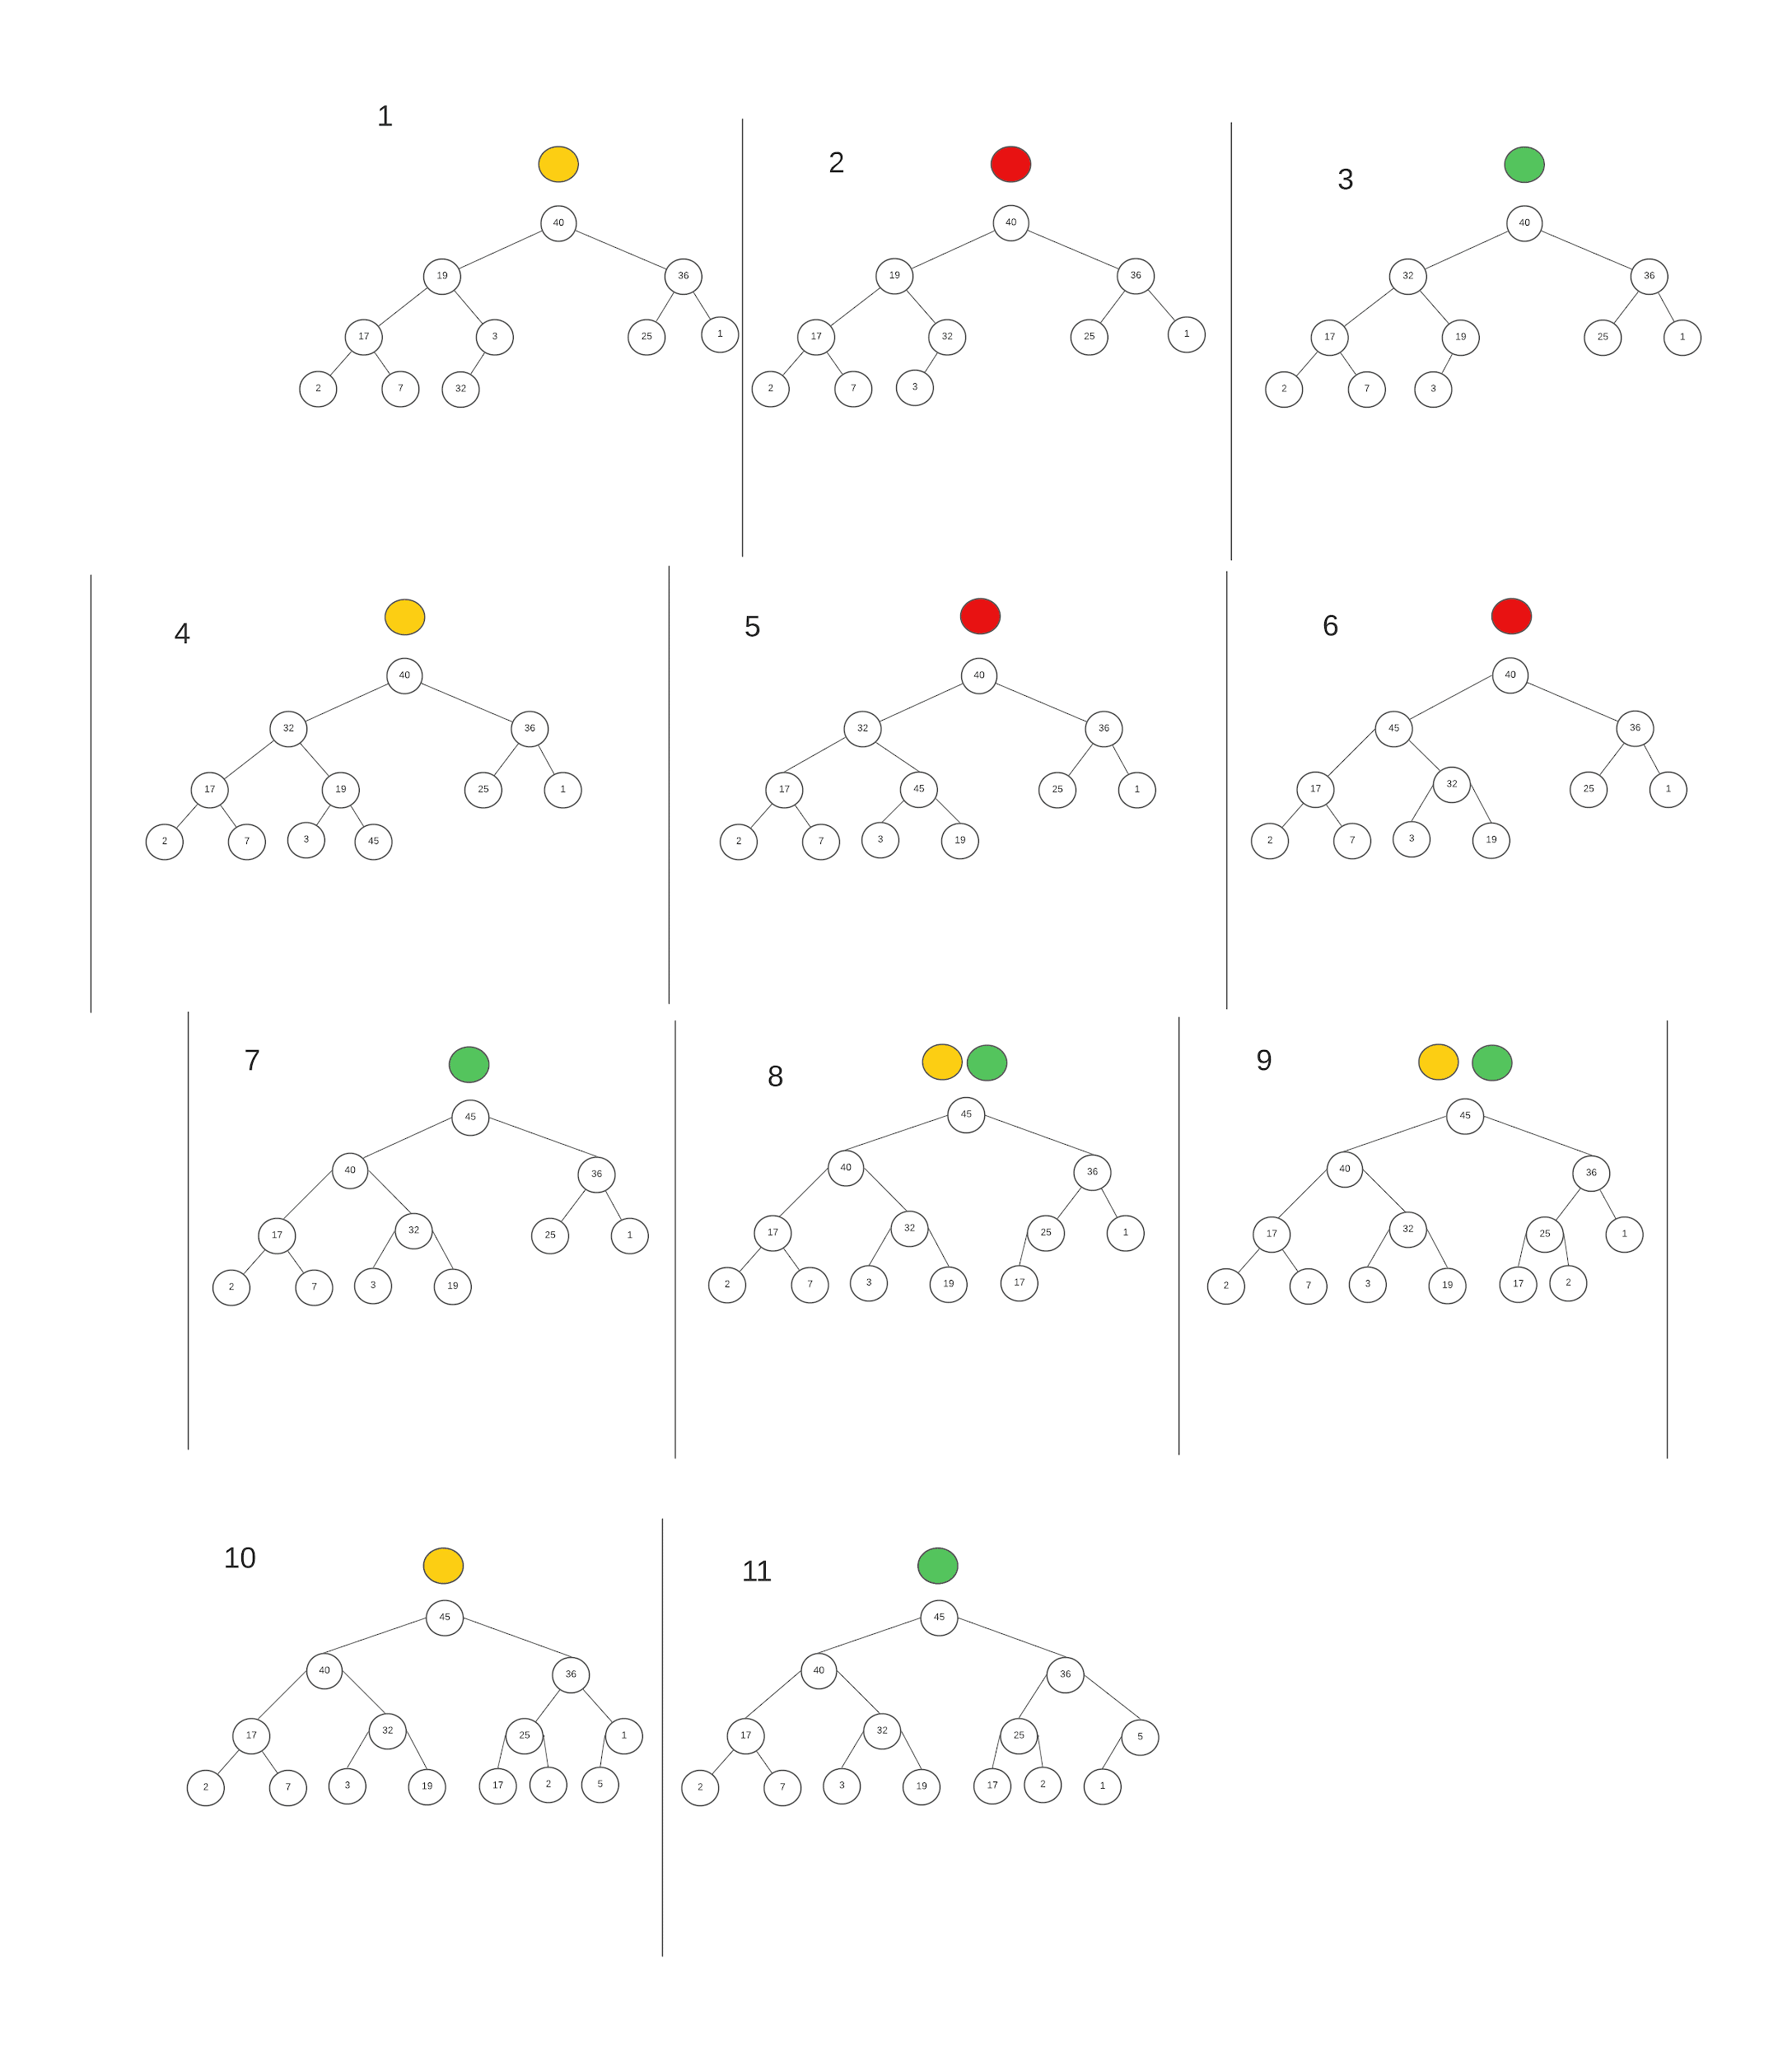

Aplique a remoção do máximo 4 vezes e mostre visualmente como a heap fica após cada operação.

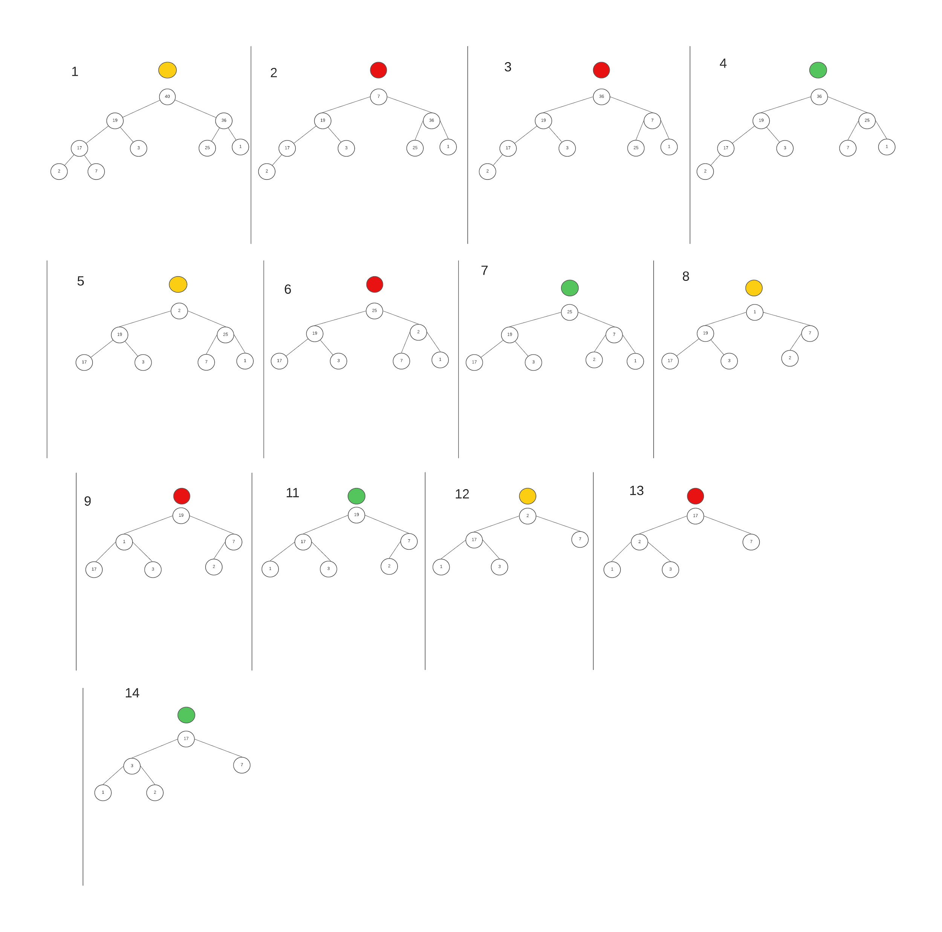

Ordene as listas a seguir utilizando o quick sort (padrão e randomizado)

* 5, 2, 6, 1, 3, 4
* 13, 19, 9, 5, 12, 8

